Garden project

Anhelina Potapenko  
[20126418@tafe.wa.edu.au](mailto:20126418@tafe.wa.edu.au)

Project Overview:

Georges Green Garden is a gardening website made with Bootstrap Framework.   
The website has four main pages: Home, About, Product and Contact. Shows different types of garden items. The design is green and natural. Homepage has carousel, gallery products and two video with gardening tips. The goal of this website is to help people find beautiful garden products and learn more about gardening.

The purpose of this website is to promote the shop’s products, share gardening inspiration, and allow customers to easily contact the store.

The website was built using the WordPress CMS, customised with the Bootstrap 5 framework and Advanced Custom Fields (ACF) for dynamic content.

Style Guide:

**Design Theme:**  
Clean, fresh, and natural aesthetic representing a green and eco-friendly gardening brand.

**Colour Palette:**

Green (#198754;) — primary brand colour (nature, growth)

White (#ffffff) — background for clean layout

**Typography:**

font-family: 'Arial', sans-serif;

**Imagery:**

Use high-quality photos of plants, gardens, pots, and tools that reflect freshness, nature, and sustainability.

**Logo:**

“Georges Green Garden” logo with a leaf icon (used in header and favicon) was designed in Canva.

**Layout:**

Grid-based layout using Bootstrap 5, ensuring responsiveness across mobile, tablet, and desktop devices.

**Images:**

<https://unsplash.com/>

A Style Guide:

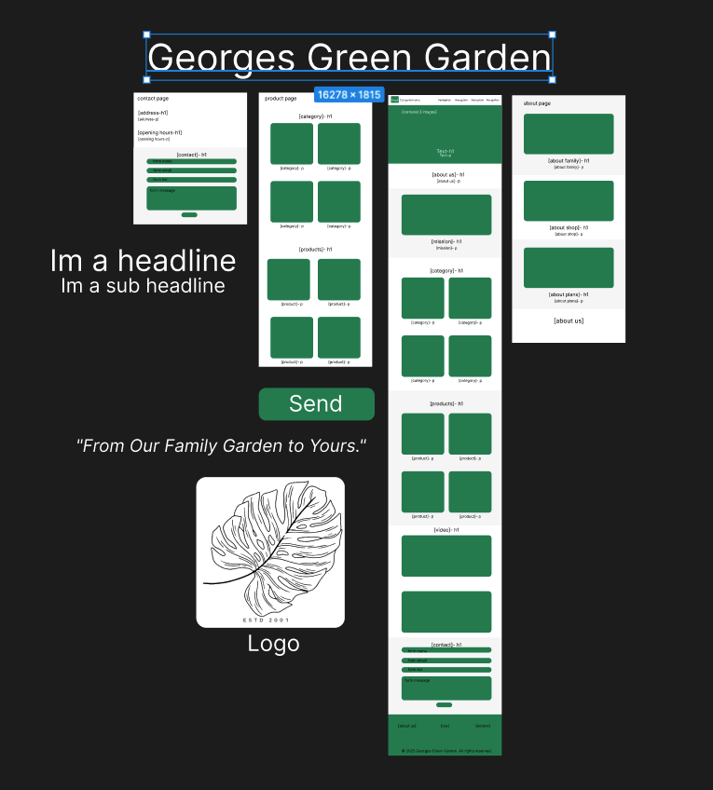

Functional Specifications

The website includes the following key features:

Homepage: Carousel banner, welcome message, and product category cards.

About Page: Information about the family business, history, and goals.

Products Page: Gallery of product categories (plants, pots, tools, fertilisers, gifts).

Contact Page: Contact form, image section, quote, and company details.

Video Section: Embedded YouTube tutorials via ACF.

Responsive Design: Adjusts automatically for all screen sizes.

Custom Fields: Managed through Advanced Custom Fields (ACF).

Navigation Menu: Links to all main pages in the header and footer.

Plugins

Advanced Custom Fields (ACF)

Wordpress:

ACF -> Install -> Activate

Pages:

Creating page, Pages -> Add page -> Add title: Home -> Publish

Creating page, Pages -> Add page -> Add title: About -> Publish

Creating page, Pages -> Add page -> Add title: Product -> Publish

Creating page, Pages -> Add page -> Add title: Contact -> Publish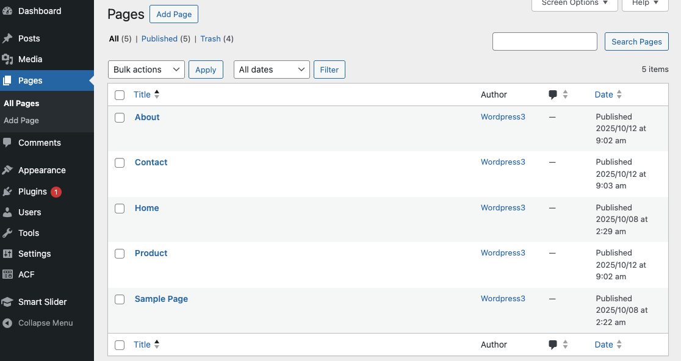

Creating Menu:

Appearance -> Menus

In Menu structure -> Menu Name: Garden Shop -> Display location -> main menu -> Save menu

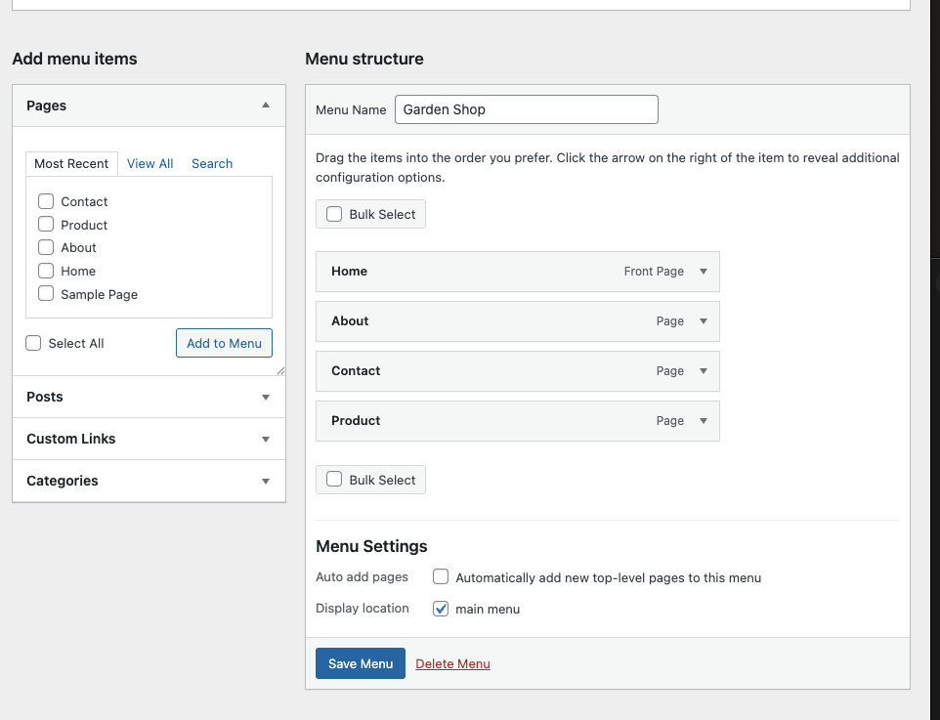

Add menu to the navigation:

Menus -> Choose: Garder Shop -> Menu location: main menu -> Publish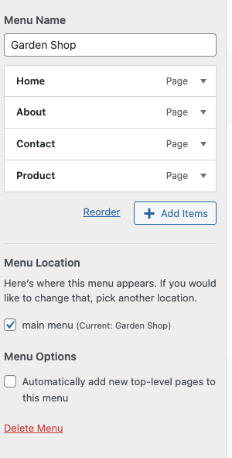

Connecting Wordpress page to our page:

Homepage seetings -> Homepage: Home -> Publish

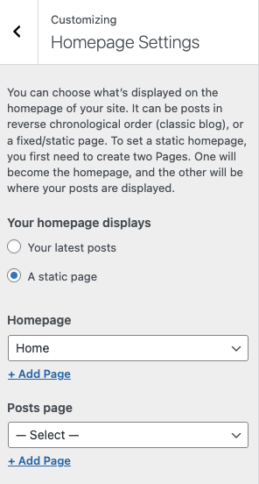

Pages -> About -> Template -> About page -> Save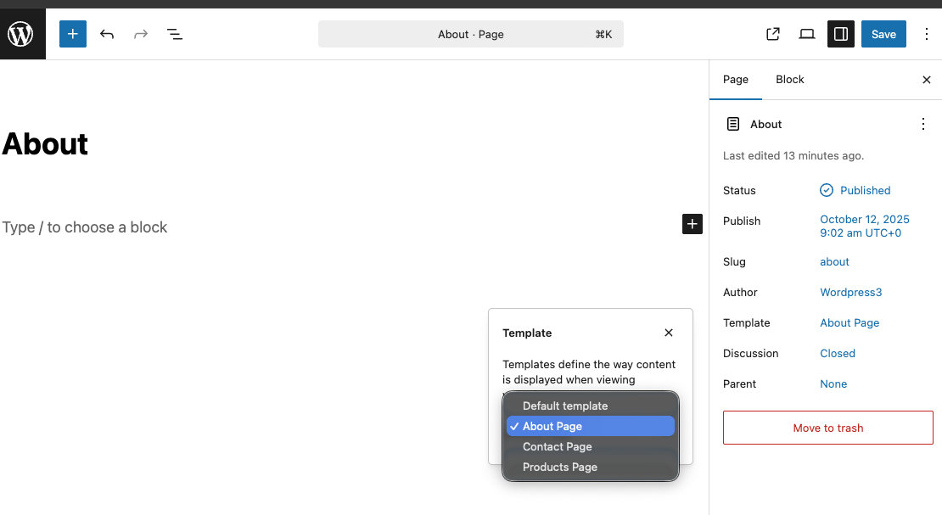

Doing the same with another pages

Pages -> Contact -> Template -> Contact page -> Save

Pages -> Product -> Template -> Product page -> Save

Home page will connect automatically.

Now we got working navigation

On home page -> Site Identify -> Site Title: Georges Green Garden -> Site icon: logo4.png -> Publish

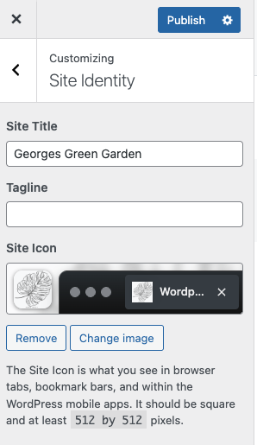

Add content to Home page:

**Carousel Section**

ACF -> Add new -> Field Group Title: Carousel Section -> Add Field ->

Field Type: image -> Field Label: carousel_image1

Add Field ->Field Type: image -> Field Label: carousel_image2

Add Field ->Field Type: image -> Field Label: carousel_image3

Add Field ->Field Type: text -> Field Label: carousel_title

Add Field ->Field Type: text -> Field Label: carousel_subtitle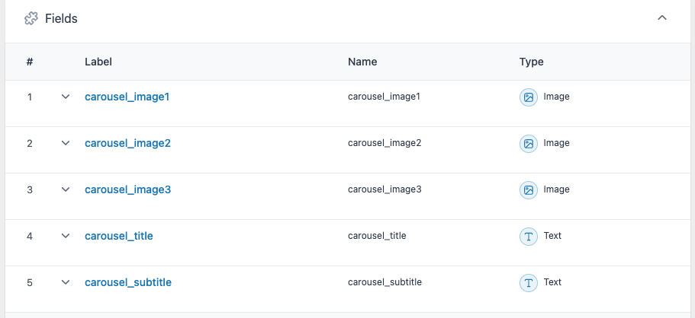

Settings:

Rules -> Page is equal to Home -> Save Changes

Pages -> Home   
We got Section where we can put text and upload images:

carousel_image1 -> images/image13.jpg

carousel_image2 -> images/image14.jpg

carousel_image3 -> images/image15.jpg

carousel_title -> Grow Naturally

carousel_subtitle -> Fresh ideas for your home & garden

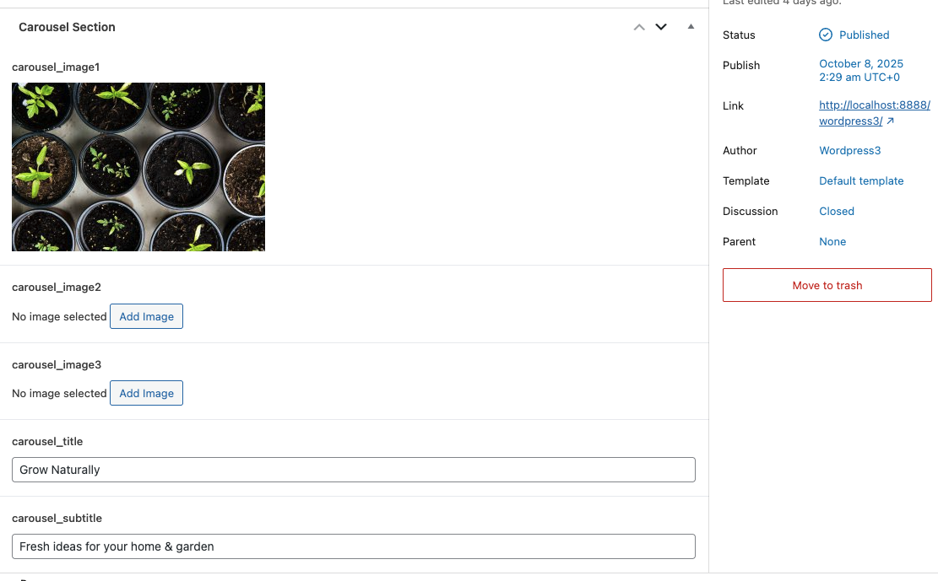

Save

We got Carousel

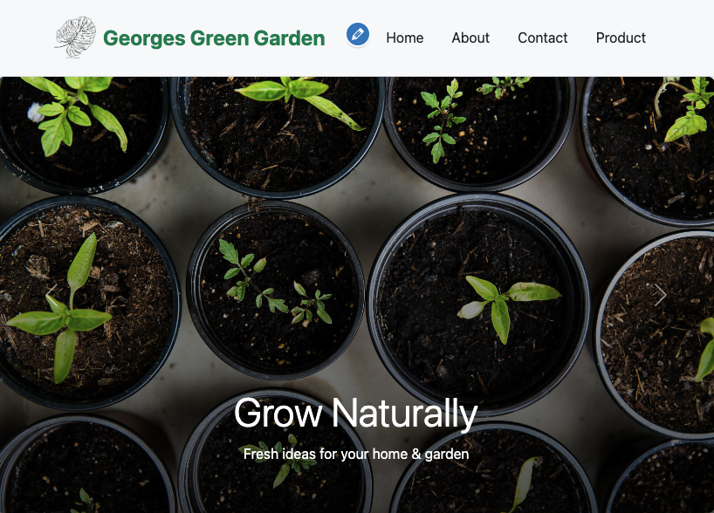

**About Section**

Field Group Title: About Section

Add Field ->Field Type: text -> Field Label: goal-h1 ->

We believe in making better gardens for everyone

Add Field ->Field Type: text -> Field Label: goal-p ->

Our shop provides plants, pots, tools, fertilisers and unique gifts to help you create your dream garden.

**Intro Section**

Add Field ->Field Type: image -> Field Label: hero_image -> "images/image04.jpg"

Add Field ->Field Type: text -> Field Label: hero_title -> Our Mission

Add Field ->Field Type: text -> Field Label: about_text -> We believe in making gardening accessible and enjoyable for everyone. From fresh fragrant plants to organic fertilisers, our shop helps you create beautiful and sustainable green spaces.

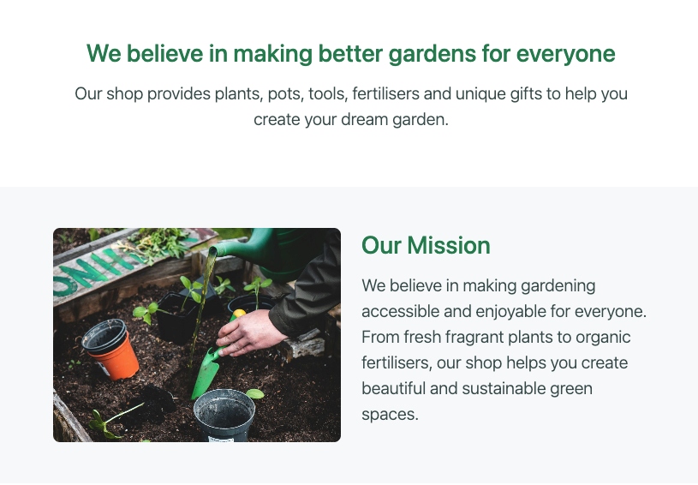

**Categories Section**

Add Field ->Field Type: text -> Field Label: category-h1-> Shop by Category

Add Field ->Field Type: image -> Field Label: category_image1 -> images/image05.jpg

Add Field ->Field Type: text -> Field Label: category_name1 -> Plants

Add Field ->Field Type: image -> Field Label: category_image2 -> images/image06.jpg

Add Field ->Field Type: text -> Field Label: category_name2 -> Pots

Add Field ->Field Type: image -> Field Label: category_image3 -> images/image07.jpg

Add Field ->Field Type: text -> Field Label: category_name3 -> Garden Tools

Add Field ->Field Type: image -> Field Label: category_image4 -> images/image08.jpg

Add Field ->Field Type: text -> Field Label: category_name4-> Fertiliser

**Videos Section**

Add Field ->Field Type: text -> Field Label: videos-h1-> Gardening Tips & Tutorials

Add Field ->Field Type: URL -> Field Label: video_1_url -> https://www.youtube.com/embed/iFwFRdY3KtU

Add Field ->Field Type: URL -> Field Label: video_2_url -> <https://www.youtube.com/embed/jXoe-jjIYc4>

**Home page:**

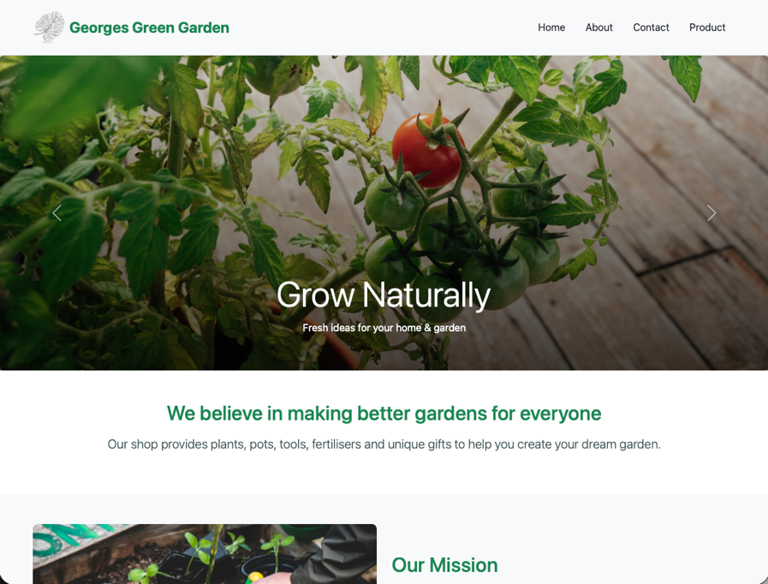

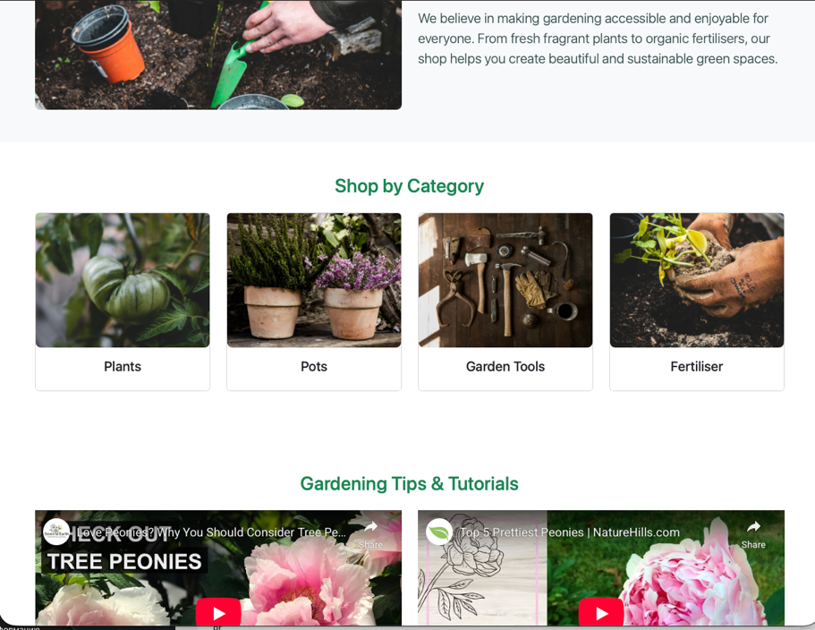

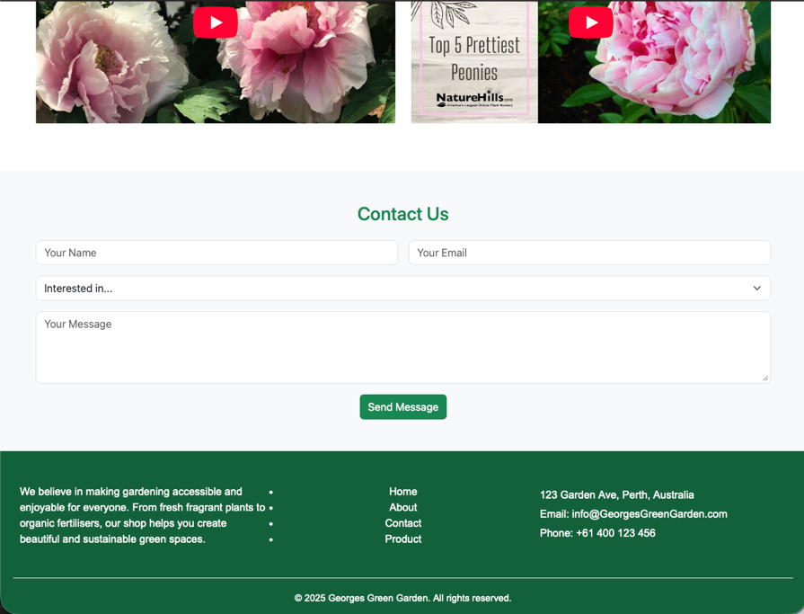

**ACF:**

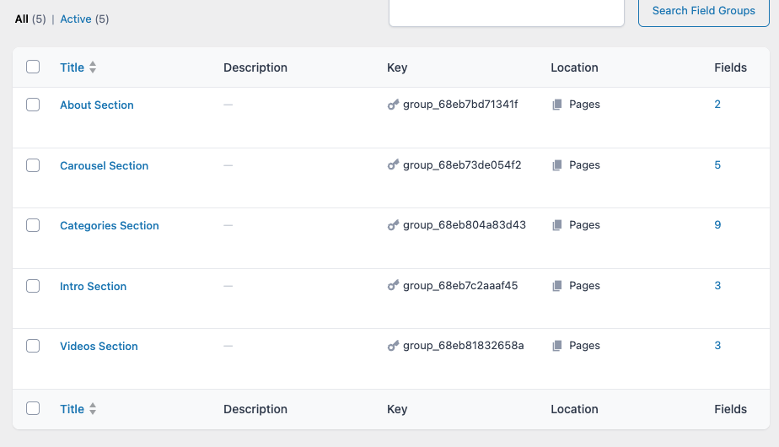

**Home Page in Pages**

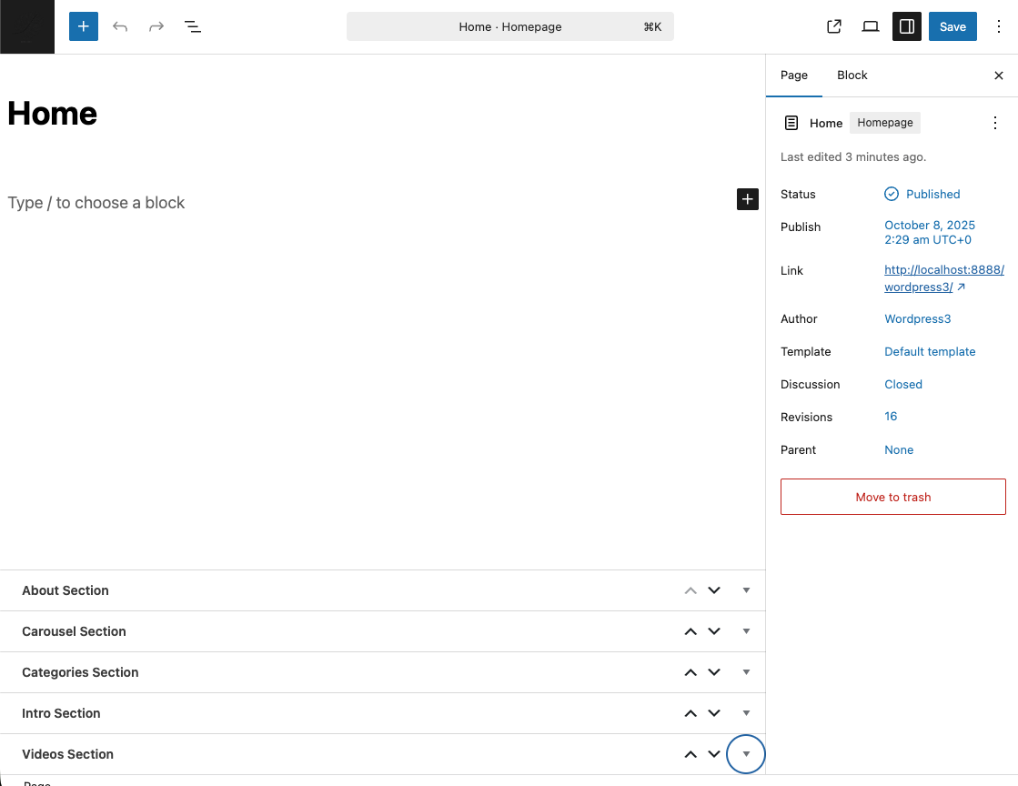

Add content to About page:

Rules -> Page is equal to About -> Save Changes

**About Our Family**

Add Field ->Field Type: text -> Field Label: about_family_h1-> About Our Family

Add Field ->Field Type: text -> Field Label: about_family_p-> Since 2001, our garden shop has been a proud family-run business. Gardening runs in our blood, and we love sharing our passion with our community. Every member of our family contributes their expertise and care, making sure each customer feels welcomed and supported.

Add Field ->Field Type: image -> Field Label: about_family_image-> images/image19.jpg

**About Our Shop**

Add Field ->Field Type: image -> Field Label: about_shop_image -> images/ image17.jpg

Add Field ->Field Type: text -> Field Label: about_shop_h1-> About Our Shop

Add Field ->Field Type: text -> Field Label: about_shop_p -> Our shop offers a wide range of plants, seeds, tools, and organic fertilizers to help you grow a beautiful and sustainable garden. We focus on quality, freshness, and eco-friendly solutions, ensuring that every product you take home brings joy and lasting value.

**Our Goals & Plans**

Add Field ->Field Type: text -> Field Label: goals_h1 -> Our Goals & Plans

Add Field ->Field Type: text -> Field Label: goals_p -> We aim to inspire more people to connect with nature and enjoy gardening. In the coming years, we plan to expand our plant variety, introduce gardening workshops, and create community events that promote sustainability and green living. Our vision is to help everyone cultivate a garden that brings happiness and harmony.

Add Field ->Field Type: images -> Field Label: goals_images -> images/image18.jpg

**Quote**

Add Field ->Field Type: text -> Field Label: about_quote -> "From Our Family Garden to Yours."

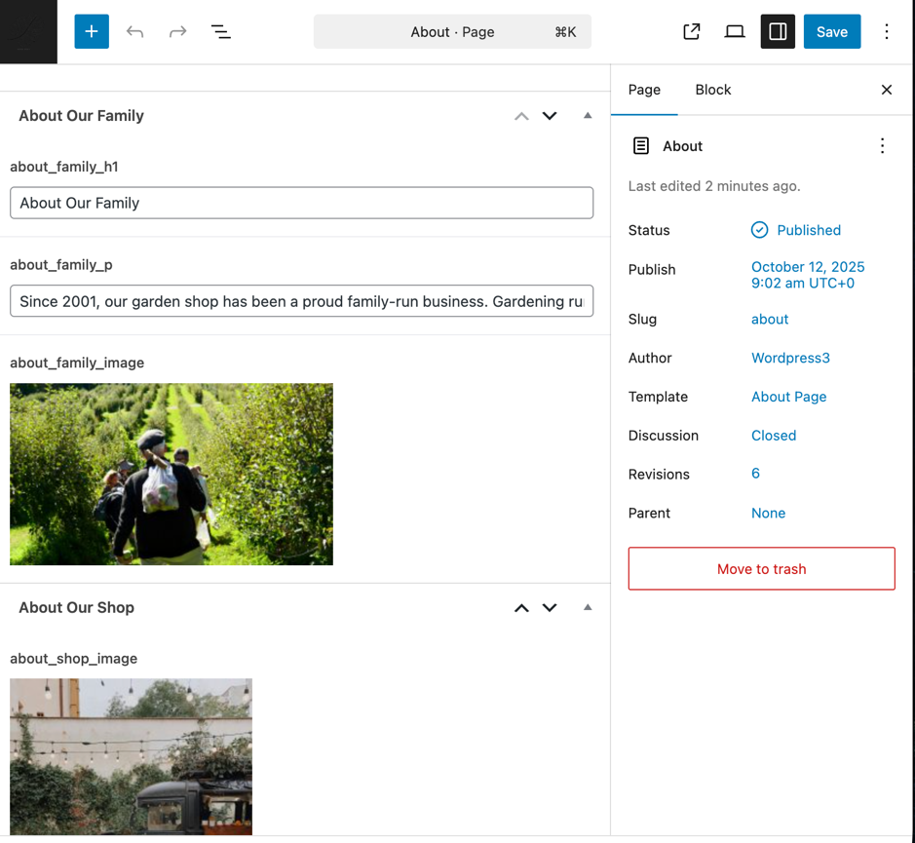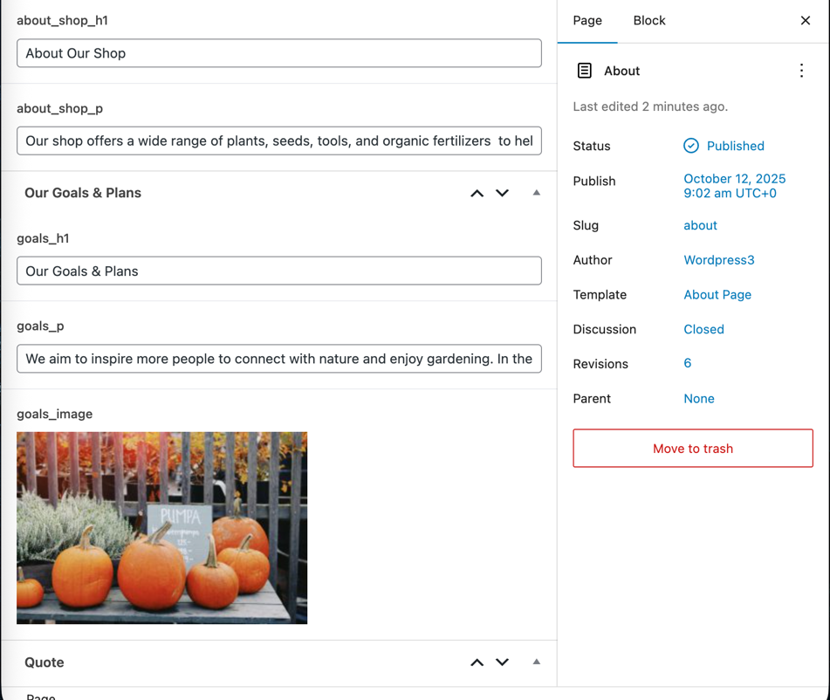

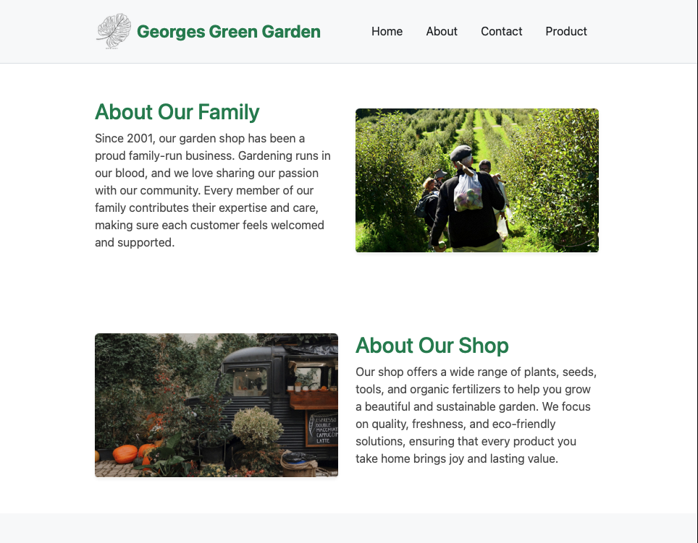

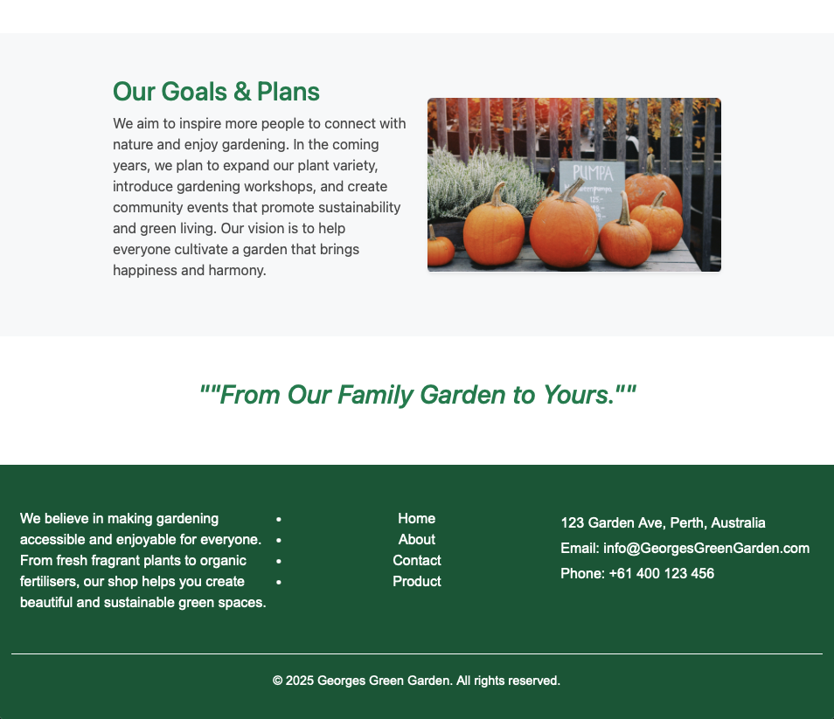

Contact Page:

Rules -> Page is equal to Contact -> Save Changes

**Header Section**

Add Field ->Field Type: text -> Field Label: contact_h2 ->

**Contact Intro Section**

Add Field ->Field Type: text -> Field Label: contact_intro -> Contact Us

**Image Section**

Add Field ->Field Type: text -> Field Label: contact_image -> images/image15.jpg

**Quote Section**

Add Field ->Field Type: text -> Field Label: contact_quote -> "From Our Family Garden to Yours."

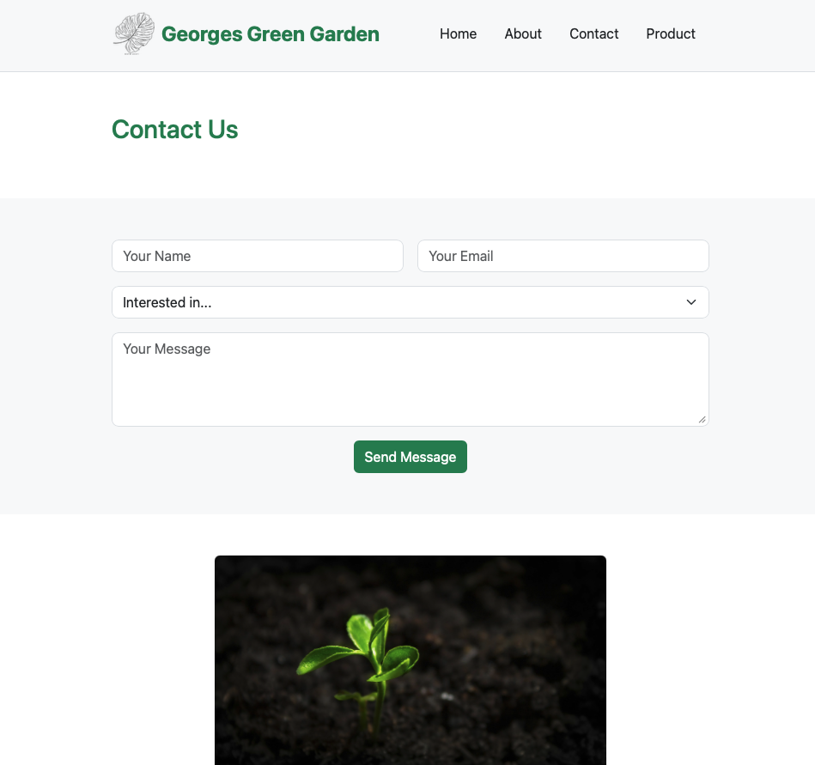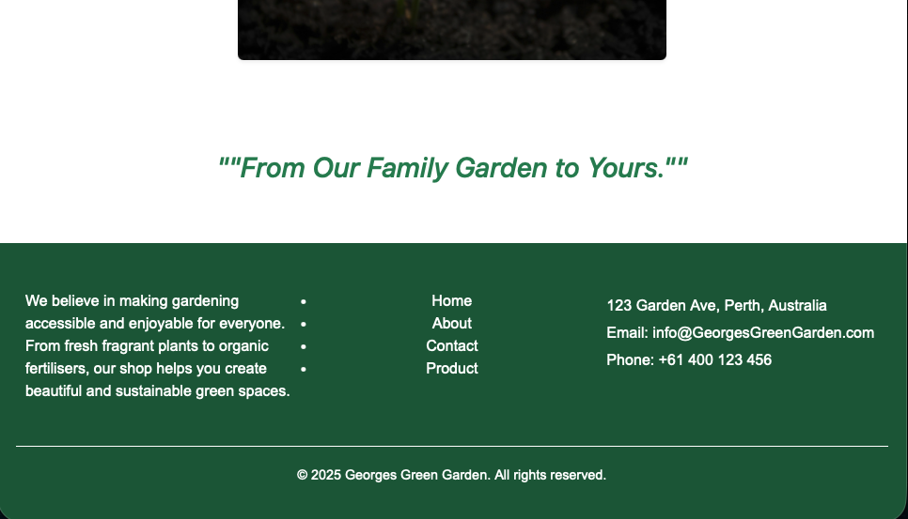

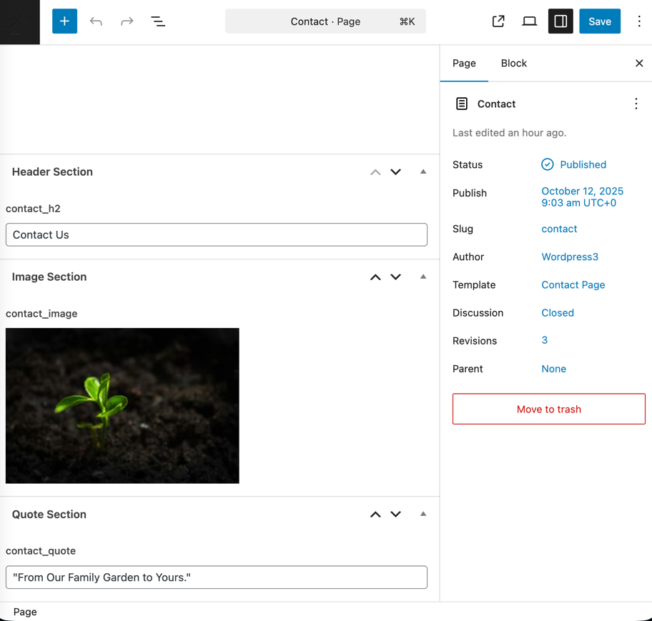

Product Page:

Rules -> Page is equal to Contact -> Save Changes

**Product Section**

Add Field ->Field Type: text -> Field Label: products_h2-> Our Product

**Product Type**

Add Field ->Field Type: text -> Field Label: product1_name-> Roses

Add Field ->Field Type: image -> Field Label: product1_image-> images/image20.jpg

Add Field ->Field Type: text -> Field Label: product2_name-> Succulents

Add Field ->Field Type: image -> Field Label: product2_ image -> images/image21.jpg

Add Field ->Field Type: text -> Field Label: product3_name-> Orchidss

Add Field ->Field Type: image -> Field Label: product3_ image -> images/ image22.jpg

Add Field ->Field Type: text -> Field Label: product4_name-> Tulips

Add Field ->Field Type: image -> Field Label: product4_ image -> images/image23.jpg

**Product Type 2**

Add Field ->Field Type: text -> Field Label: products_h4-> Pots

Add Field ->Field Type: text -> Field Label: product5_name-> Terracotta Pots

Add Field ->Field Type: image -> Field Label: product5_image -> image28.jpg

Add Field ->Field Type: text -> Field Label: product6_name-> Ceramic Pots

Add Field ->Field Type: image -> Field Label: product6_image -> images/image29.jpg

Add Field ->Field Type: text -> Field Label: product7_name-> Wooden Pots

Add Field ->Field Type: image -> Field Label: product7_image -> images/image35.jpg

Add Field ->Field Type: text -> Field Label: product8_name-> Hanging Pots

Add Field ->Field Type: image -> Field Label: product8_ image -> images/image49.jpg

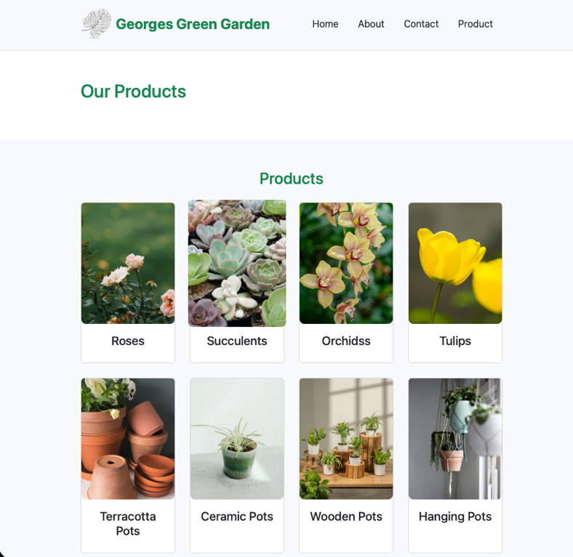

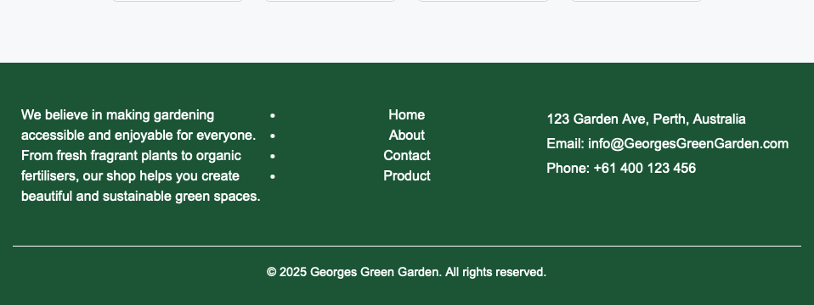

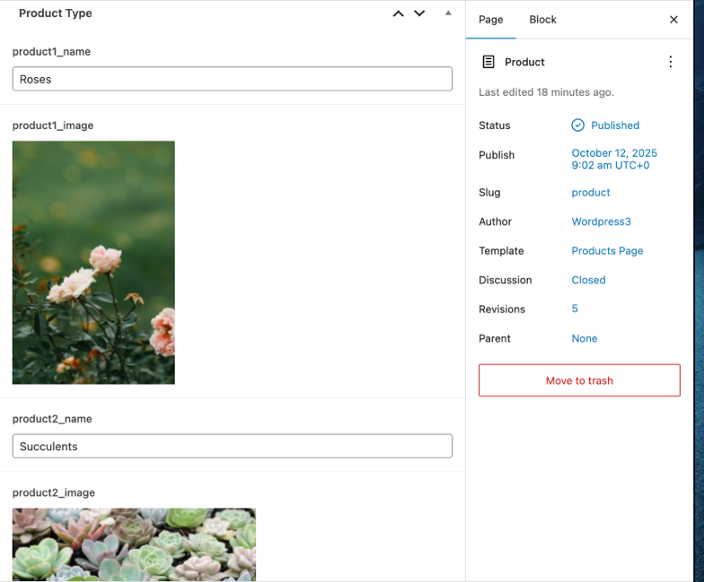

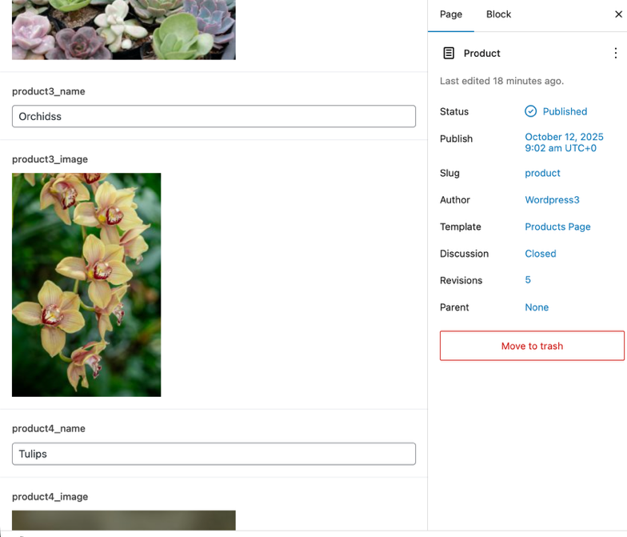

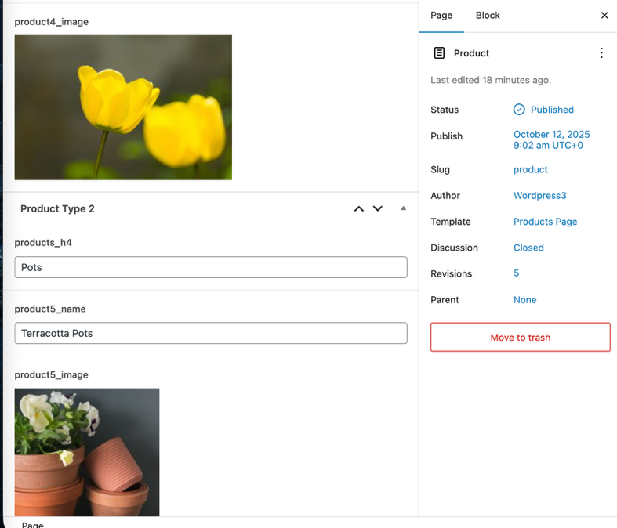

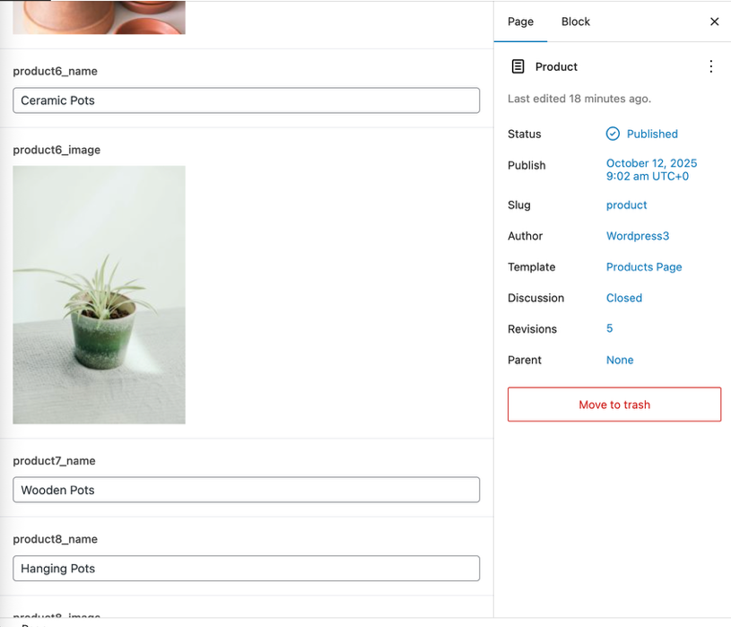

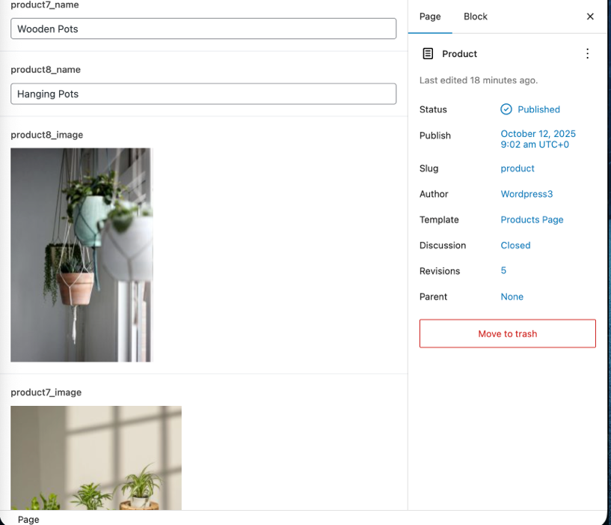

**ACF:**

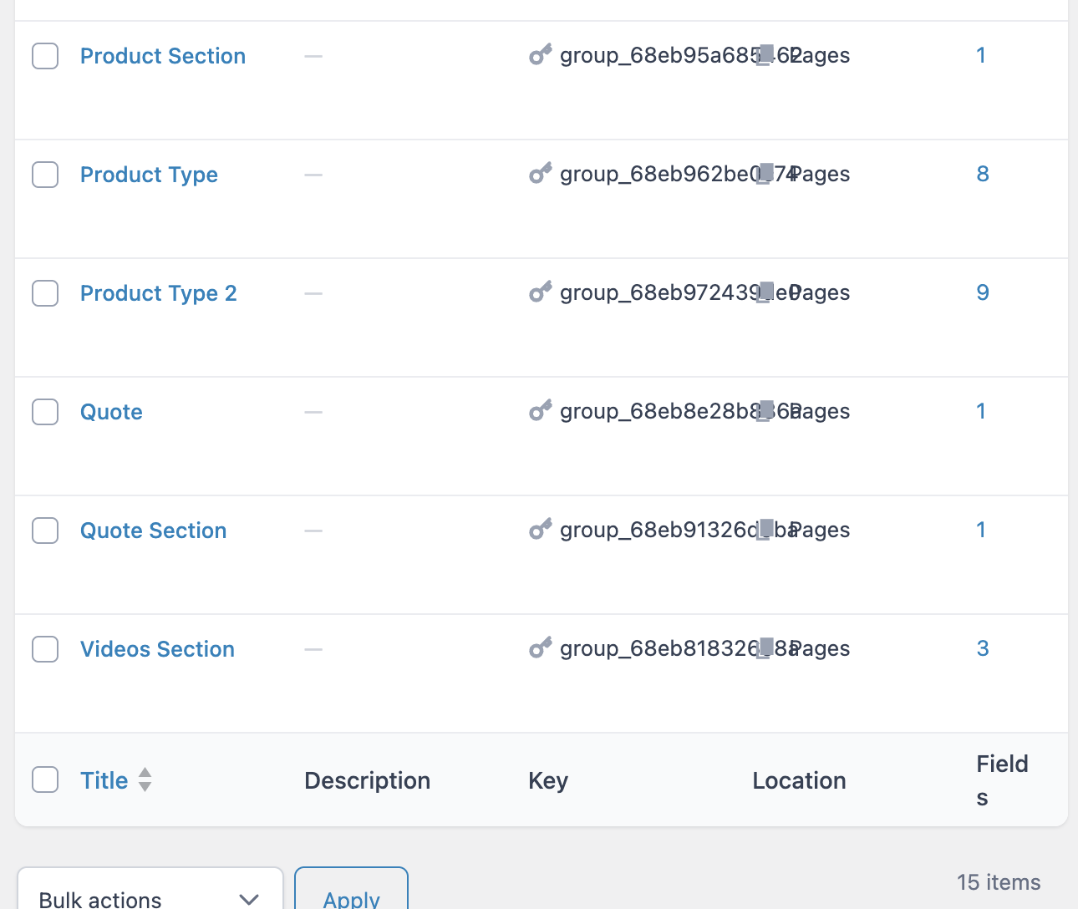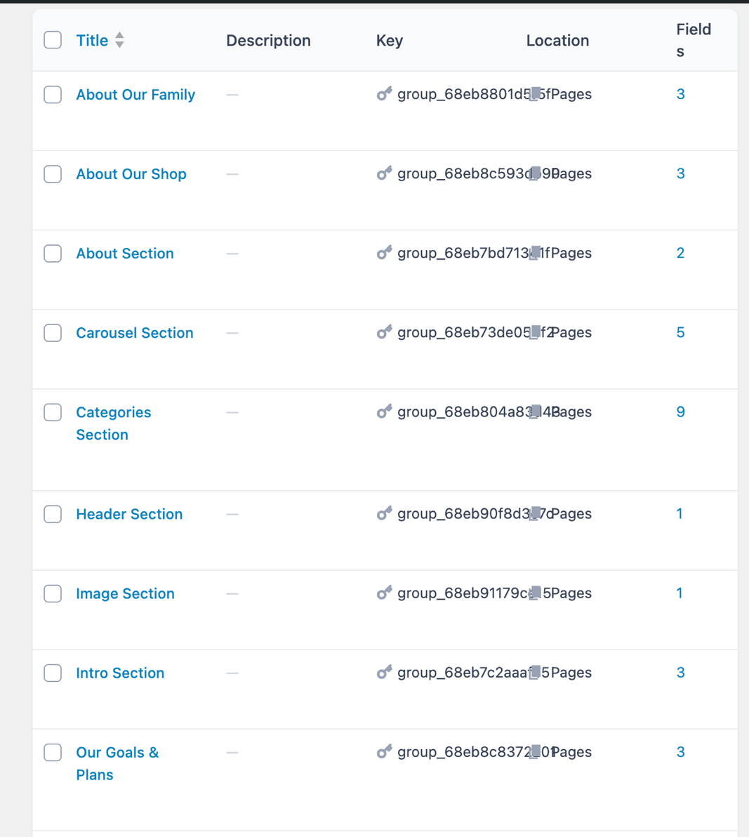

**Notes:**

If text or image to showing on the page, must check Filed Name in ACF, because space will looks like “_”.

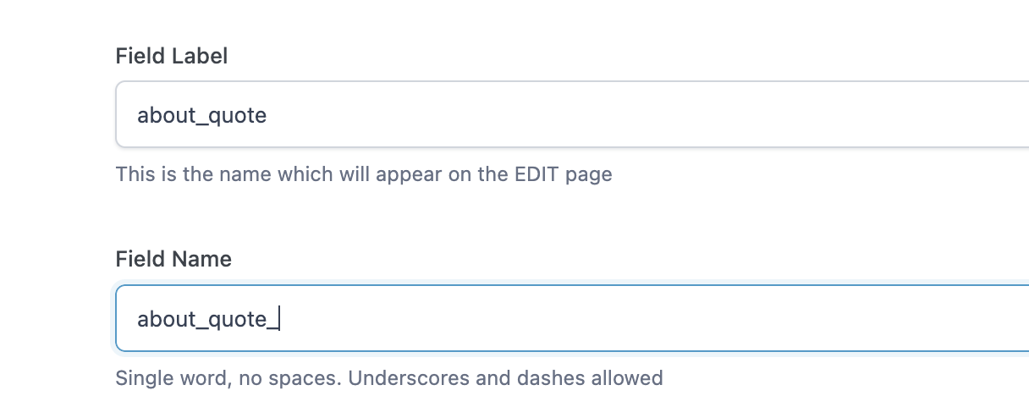

Validation:

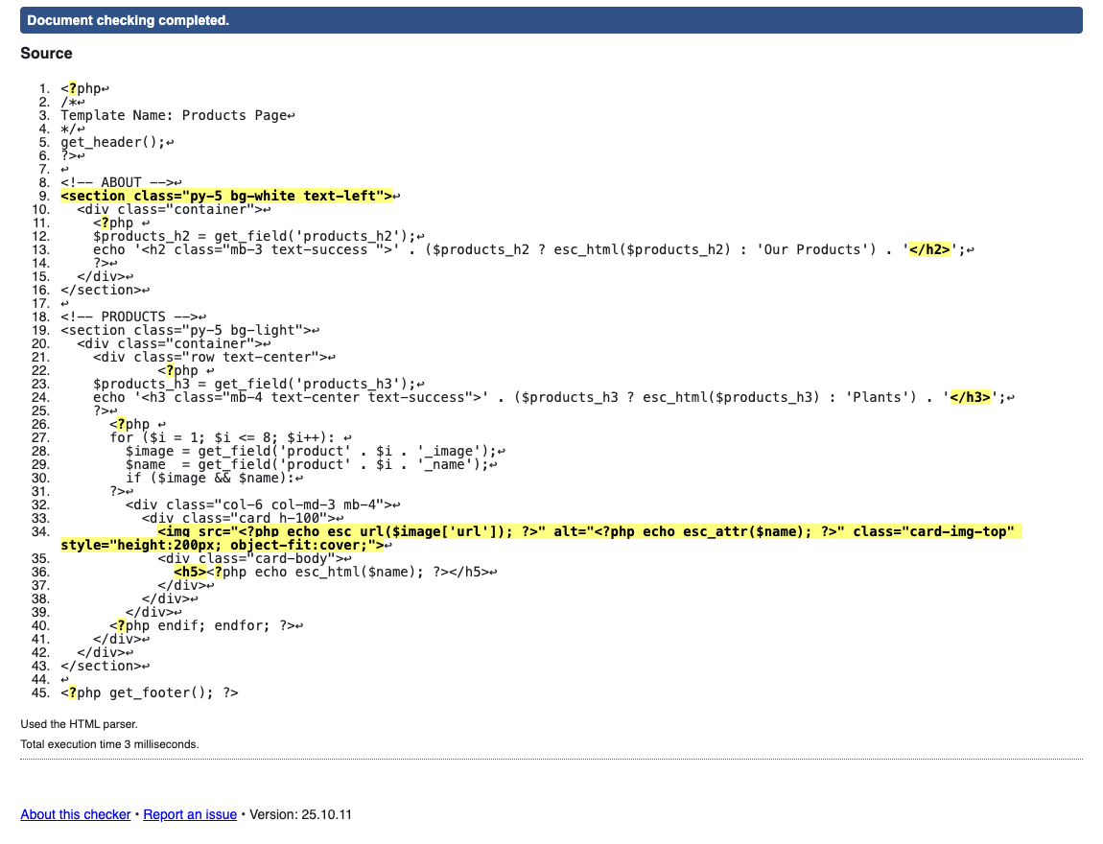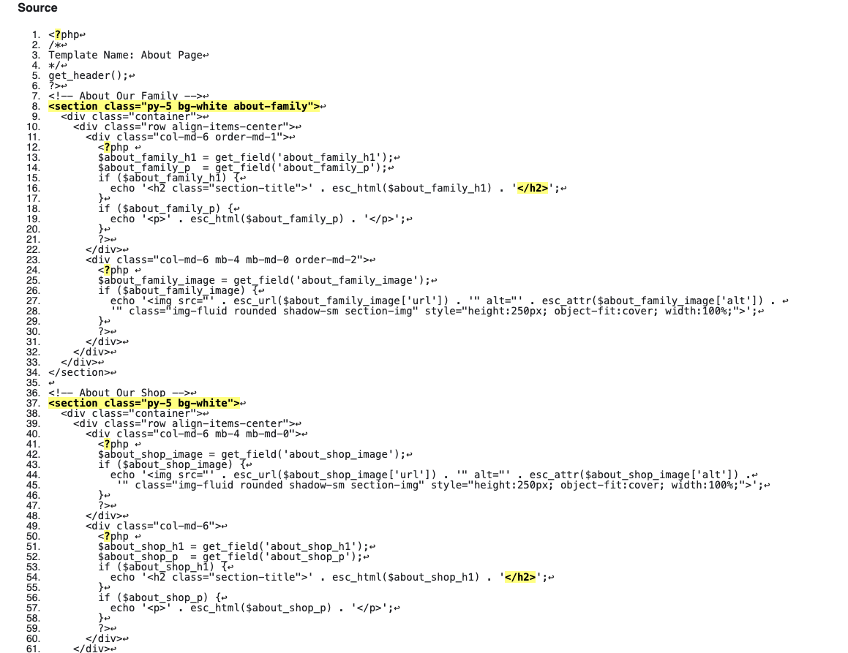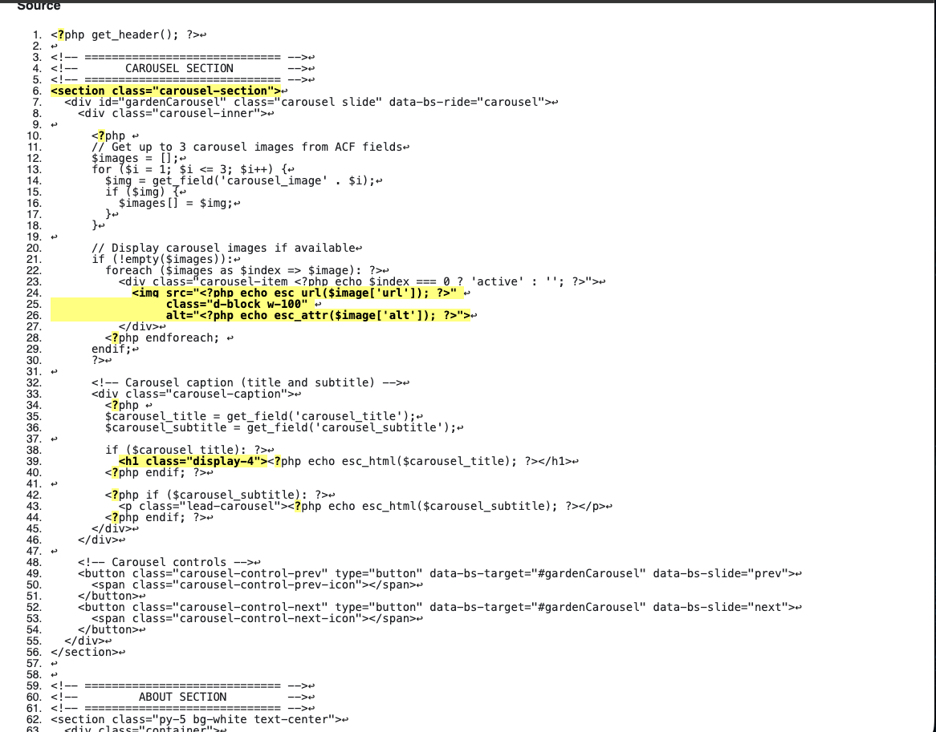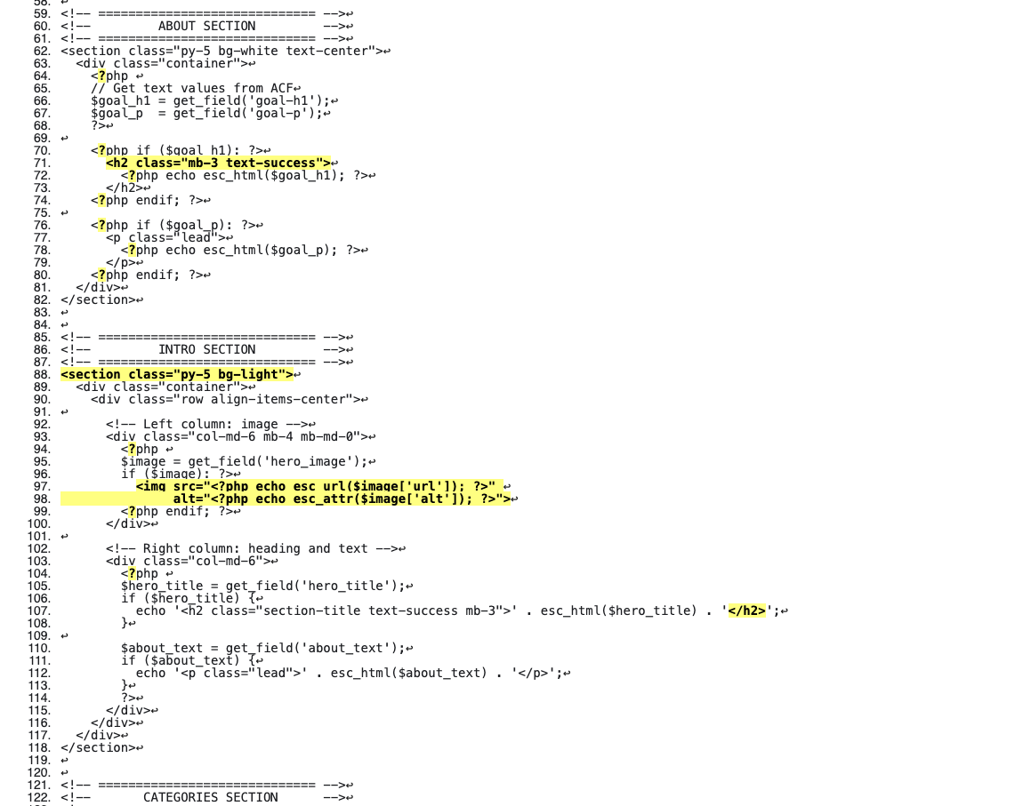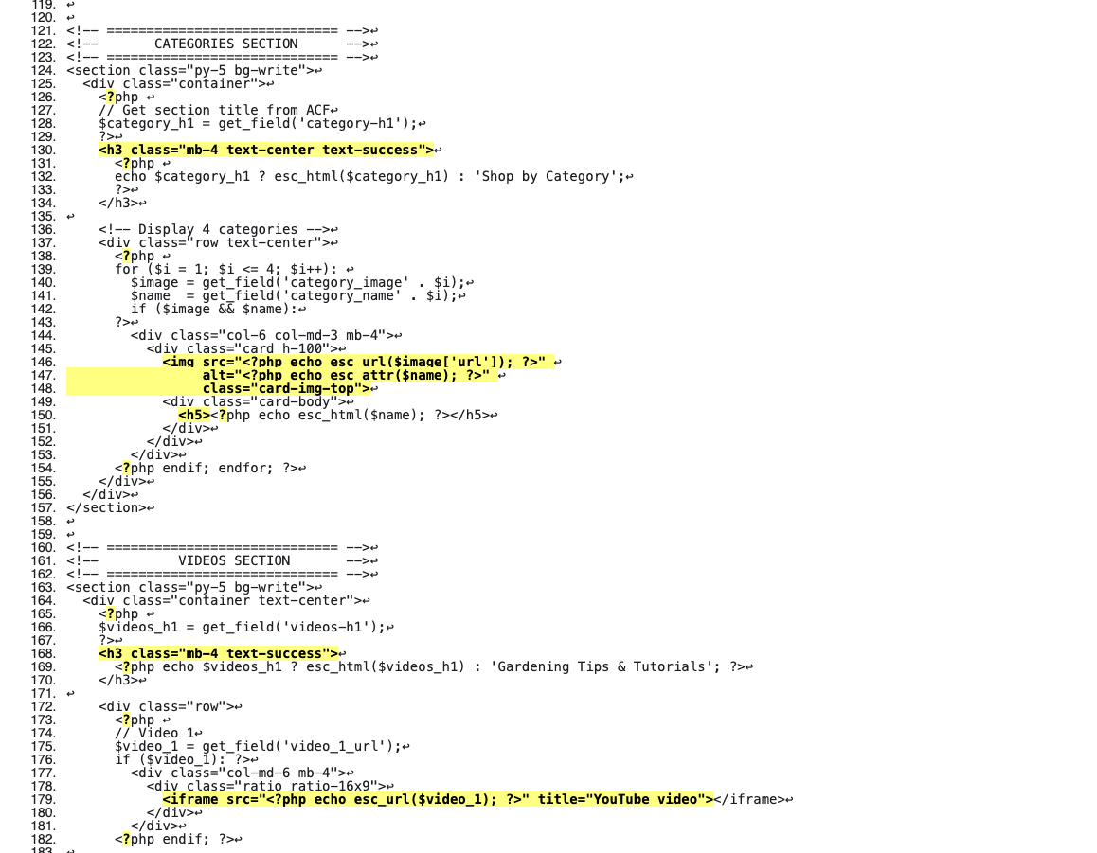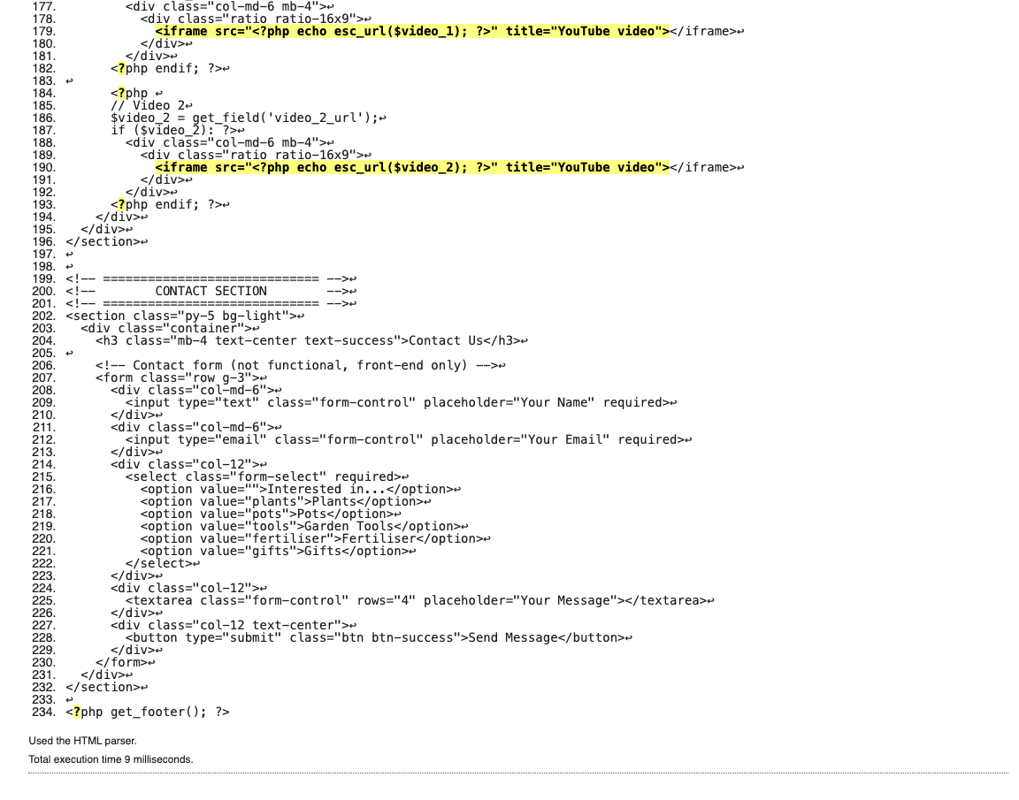

Wordpress3 :

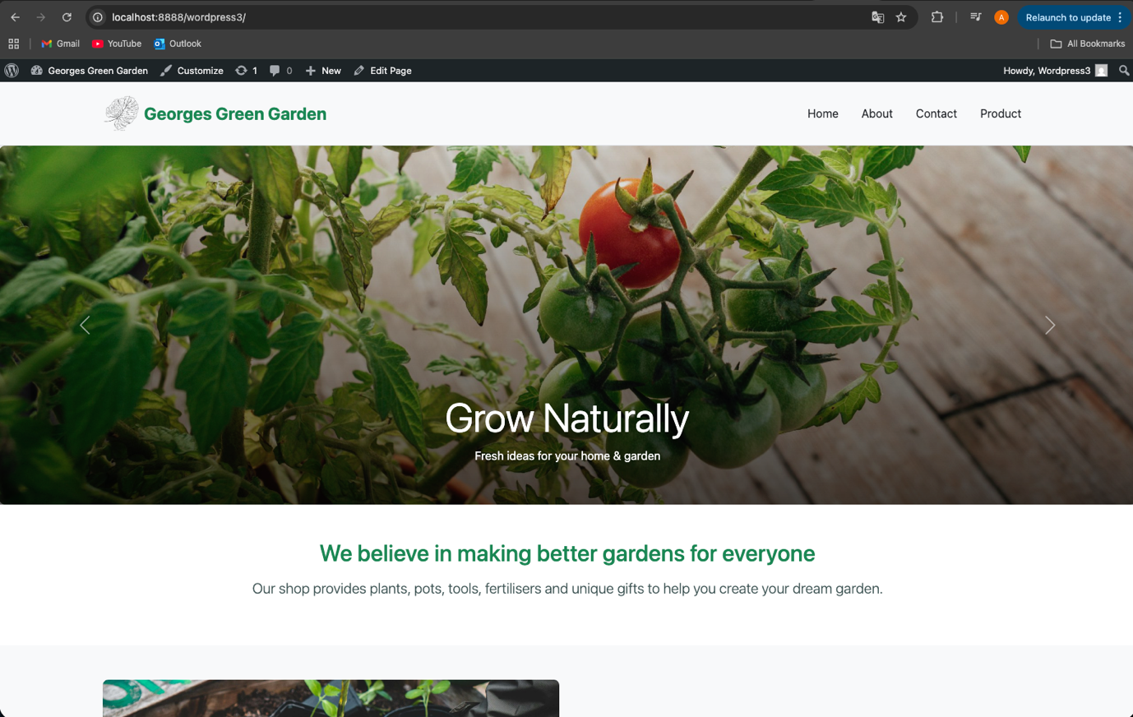

Wordpress 1:

